Ideation Phase
Empathize & Discover

Date | 27 January 2026
Team ID | LTVIP2026TMIDS26598
Project Name | Prevent User Deletion If Assigned to Incident
Maximum Marks | 4 Marks

What is an Empathy Map?

The Empathy Map helps us understand the real experiences, challenges, and expectations of the primary users of the ServiceNow ITSM platform — such as System Administrators, IT Support Agents, and End Users who raise incidents. By analyzing what users say, think, do, and feel, we can design a Business Rule that effectively prevents accidental deletion of users who are assigned to active incidents.ServiceNow Administrator / IT Support Manager
Our primary user is a ServiceNow Administrator responsible for:
- Managing user accounts
- Handling incident assignments
- Maintaining workflow accuracy
- Ensuring system reliability
They work daily with the Incident table and User table in ServiceNow.

Empathy Map – ServiceNow Administrator

Says
- “Why did this incident lose its assigned user?”
- “Who deleted this user?”
- “This is affecting our workflow.”
- “We need better system control.”

Thinks
- Data integrity is very important.
- Incident ownership must not break.
- The system should prevent risky actions automatically.
- Manual monitoring is not efficient.

Feels
- Worried about accidental deletions
- Responsible for maintaining system stability
- Frustrated when workflows break
- Pressured to avoid service disruptions

Does
- Assigns incidents to users
- Creates and manages user accounts
- Configures Business Rules
- Monitors incident lifecycle
- Tests system configurations
If a user assigned to an active incident is deleted:
- Incident ownership becomes unclear
- Workflow continuity breaks
- Reporting accuracy reduces
- Accountability is lost
This creates operational risk in IT service management.

Solution Based on Empathy
To solve this real-world administrative problem, we implemented:
👉 A Before Delete Business Rule on the sys_user table
👉 That checks the incident table using GlideRecord
👉 Blocks deletion if the user is assigned to any incident
👉 Displays an error message
👉 Preserves system integrity
Example:
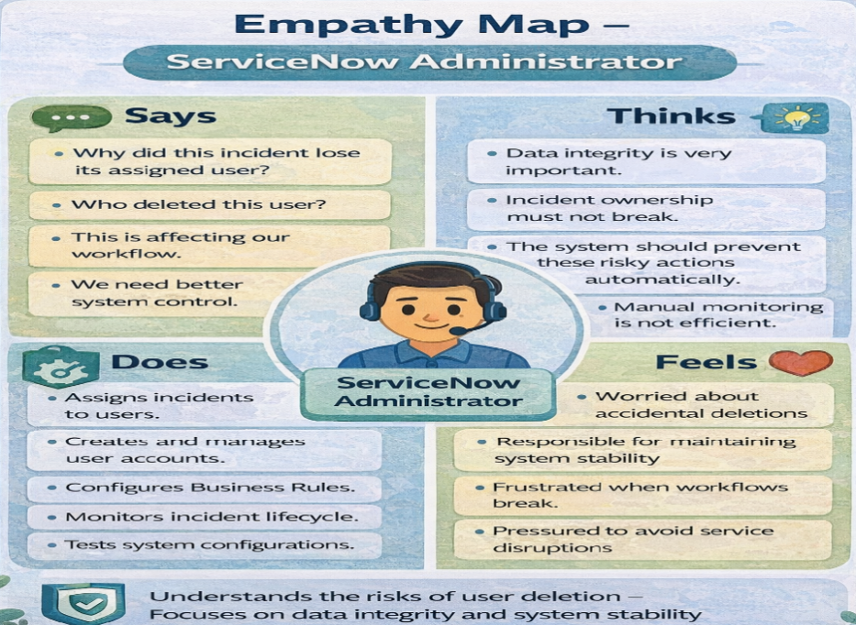
Reference: https://www.mural.co/templates/empathy-map-canvas

